Claudoperation — design doc
Nov 3, 2026 · @Martin

Premise and goals
Claudoperation lets teammates who each work with Claude learn what the others did, by reading a short, human-approved story instead of the AI output.
Premise (v1.2). When AI produces most of the output, the process behind it matters as much as the product. People working independently with AI see only each other's product, never the human-AI process behind it. A human cannot consume the full AI record, and a verbatim transcript is too context-bound to help a newcomer. Humans also value other humans' intellectual contribution more than the AI's.
What Claudoperation does. For each session, Claude drafts a short story of claims. Each claim carries its origin (human or AI), a contribution type, and, for AI claims, whether a human reviewed it. The human approves the story before it is shared. The reader's first question is answered first: what did my teammate do?
Goals, in priority order.
- Cooperation: teammates know what was decided, who drove it, and which AI decisions nobody has checked.
- Self catch-up: authors recover their own reasoning quickly.
- Credit: emerges as a side effect of analytics over the labels. It is not a target.
Out of scope. Direct human writing outside AI sessions is left unassigned. Full transcripts are not shared for now; a reader's AI reads the product directly, guided by the approved stories.

Design overview
Two loops share one artifact: the author's approved session record, which the teammate reads before any AI output.
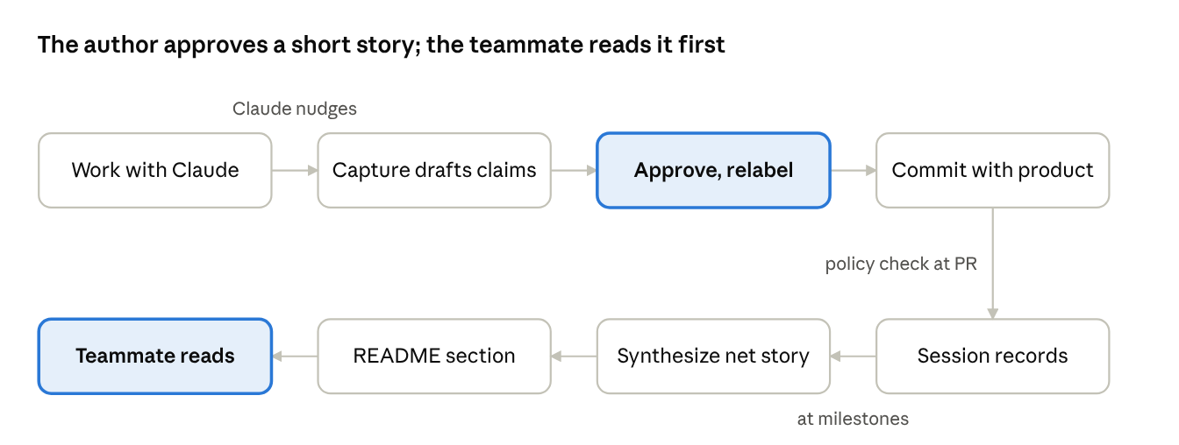
author loop and reader loop · 8 steps
The author's only work is approving and relabeling; Claude drafts everything else. What gets drafted and checked depends on whether the touched paths are endorsed or functional (see Capture policy).

Session record and contribution taxonomy
Each session yields one record: a story of at most about 300 words, made of approved claims, each with an origin, one contribution label, and a review state.
Record rules
- One record per session, incremental: a long chat yields several records, each covering only what happened since the previous capture.
- One screen per record, with a strong default style guide (lead with the decision, define jargon, one idea per sentence) that teams can override.
- Stored as Markdown with YAML frontmatter at sessions/<member>/<date>-<id>.md, beside the product. Metadata folds into <details> blocks.
- Records are like commits: append-only, viewable one by one, revertable. Evidence links point into the product (files, commits). Optional link fields between claims (`led_to`, `supersedes`, `depends_on`) are in the schema from v1, approved with the claims, so later diagrams never need re-capture.
Contribution labels (human-originated claims; one primary label each, no weighting)
Label | Meaning | Evidence required
Direction | Set the goal or scope | No
Choice | Picked one of the AI's options | No
Origination | Proposed an idea the AI had not | Yes: not proposed earlier by the AI
Correction | Fixed an AI error or wrong assumption | Yes: the error corrected
Knowledge | Supplied domain facts or data | No
Verification | Actually checked output | Yes: what was checked and how
Acceptance | Approved without substantive input | No
A claim lacking its required evidence falls back to the next weaker label.
AI-originated claims get no label in v1 but carry a review state: endorsed (a human checked and agrees) or recorded, not reviewed (default). Any teammate can later add an append-only endorsement with what they checked.

Approval UI and workflow
Capture is nudged, never forced: Claude drafts everything from the conversation, and the author only ticks, relabels and commits.
Approval UI. The Markdown draft file is the single source of truth; every interface edits it.
- Each claim has an approve checkbox, a label, and (for AI claims) an endorse checkbox. Approve and endorse start unchecked; labels are pre-filled with the AI's proposal.
- "Approve all" asks for confirmation, and its use is recorded. Relabels are recorded as "author-relabeled from X". Upgrading to an evidence-required label prompts for the evidence.
- Interfaces: Claude Code edits the file directly (v1); a local web form or a claude.ai artifact page can come later; in a repo, the same lines work as a pull request (PR) task list.
- If a session's claims exceed one screen, the skill suggests splitting the session.
Author loop
- Work with Claude as usual.
- Claude nudges once a burst of decisions settles, or before the chat grows long enough to lose early context.
- /capture drafts claims since the last capture marker. The product type of the touched paths sets what it drafts (see Capture policy).
- The author approves and relabels in the draft.
- Claude Code commits the record with the product changes; chat users download the file and add it to the repo.
- Before a milestone, the author runs /synthesize: a net story (A to C) from that member's records, optionally approved as a release. The skill nudges after about 5 captures.
The chat download step is the main friction point. The pilot tests it; a connector or shared upload folder is the likely fix.

Capture policy
The policy depends on what the product is for: products a human must stand behind get review rules; functional code gets a record of design decisions and no enforcement.
The team sets the policy in .claudoperation/policy.yml, changed by PR like any other file. Product type is declared per path, with a repo-wide default (for example docs/** endorsed, src/** functional).
 | Endorsed (proposal, paper) | Functional (working code)
What capture drafts | All claims, review state per AI claim | Design-level decisions only
Endorse checkboxes | Shown; unreviewed list surfaced | Hidden
Evidence-required labels | Enforced | Verification may cite "tests pass"
Policy levels | Off, Report, Warn, Require | Off, or "record exists" only
Low-human flagging | Off | Off
Rules common to both
- Traceable human input = human-approved claims. "Pure AI content" = AI work with no approved record.
- No ratio thresholds: insightful input can legitimately produce a lot of output, and ratios invite padding.
- The unit checked is the PR, not the commit.
- AI content is detected by author declaration (a commit trailer) plus Claude Code's co-author trailer. Line-level tools such as Git AI are an optional later integration.
- The author can override a failing check with a one-line reason, recorded in the analytics.
- Exempt: small changes, generated or vendored files, merges and reverts, paths marked out of scope.
- Non-repo products (for example Overleaf) cannot be checked: there the policy is a team agreement backed by the analytics.

Reader view and analytics
The reader enters through the repo README, where each member's section answers "what did they do" in about five lines.
A record or net story reads in this order
- What the human contributed: human-originated claims with their labels.
- The net story, in narrative form.
- Open questions.
- AI decisions not yet reviewed.
- Metadata, folded.
Net story. Sessions run A to B to C like commits. The net story tells the change from A to C, so readers can mostly skip B. Superseded decisions disappear from the story but still count in the analytics, so reversed effort is not erased. Between releases the net story is derived and labeled unapproved; the author approves it as a release at milestones.
Per-member README section (rewritten only by /synthesize, between fixed markers)
- Session count and contribution-label counts
- Human-to-AI claim ratio (informational only, never a target)
- Latest net story, or a link to it
- Unreviewed AI decisions, bulk approvals, relabels, policy overrides
Team-wide visibility, like GitHub contributor stats, is the default. Revisit if open profiles discourage sharing.

Presentation layer
Content and presentation are separate: approval attaches to claims, so the same approved claims can be rendered differently per reader without re-approval.
- Content (which claims, how compressed) is fixed and shared. This is where capture quality lives.
- Presentation (prose, outline, flowchart, timeline) is a reader-side setting. A renderer may only restate approved claims.
- Diagrams add relations such as "A led to B". They are drawn only from approved claims and approved links, never inferred by the renderer.
Version | Presentation
v1 | One strong default text style; link fields captured and approved
v1.5 | Reader picks prose, outline or flow per member section, or in catchup
v2 | Diagram renderers built from approved links

v1 scope and pilot plan
v1 needs no server: two skills, a file convention, and one script, viewed through GitHub's Markdown rendering.
In v1
- ☐ capture skill: drafts claims since the last marker, writes the checkbox draft, validates evidence, writes the session file
- ☐ synthesize skill: net story per member, release tagging, README section update
- ☐ File convention and policy file (sessions/, .claudoperation/policy.yml)
- ☐ Analytics script: label counts, ratios, unreviewed AI decisions, bulk approvals, relabels, overrides
- ☐ Default style guide
Not in v1: reader-side catchup skill (first after v1), local web form or artifact approval page, team-wide net story, reader-selected presentation and diagrams (see Presentation layer), public disclosure metric.
Pilot
- Solo, 1–2 weeks on Martin's own Claude projects: tune the style default and approval flow.
- Label reliability: on about 30 claims, compare labels from the AI, the author, and a teammate reading cold, using Cohen's kappa.
- Then 2–3 teammates, including uneven contributors and a principal investigator (PI).
\kappa = \frac{p_o - p_e}{1 - p_e}
Here p_o is observed agreement and p_e is chance agreement. Above about 0.6 reads as substantial; with 30 claims expect roughly ±0.1–0.15 uncertainty, so treat it as a sanity check. Low AI–author agreement means the definitions need work; low author–teammate agreement means the labels don't communicate.
Capture-quality test. A teammate reads a record cold and lists the session's key decisions; score that list against the author's own. Claim selection on long, meandering sessions is the riskiest unknown in the design.
Success signals: people use Claudoperation to share their AI products; teammates read the story before the output; a teammate can name the key decisions in another member's work.

Related work and differentiation
The novel part is attributing human contribution by type; session capture and decision extraction already exist and could serve as infrastructure underneath.
Tool or work | What it does | Gap relative to Claudoperation
Git AI, Agent Trace | Line-level AI vs human code attribution, % AI stats | Counts lines, not kinds of human contribution; code only
Entire | Captures full agent sessions on a git branch | Raw transcripts for audit, not a human-readable story
SpecStory | Saves and shares AI chat history as Markdown | Covers the dropped transcript-sharing goal; no attribution
JFrog Fly Decision Records | Auto-captures team decisions from agent chats, rolled up at release | Automatic, no human approval; records which teammate, not human vs AI; part of a heavy code release platform; adoption unclear
Grammarly Authorship | Tracks typed vs pasted vs AI text in Docs and Word | Character-level provenance, no decisions or contribution types
Research to read later
- Xie et al., ACL 2026: human contribution as mutual information between input and output.
- Amin, Lu and Yin, Purdue: that score is easily manipulated; provenance records are needed instead. Supports a type-based profile over a score.
- He, Houde and Weisz, IBM: perceived credit depends on contribution type.
- CoCo Matrix: a taxonomy of cognitive contributions in co-writing, applied to systems rather than individual contributions.
- DraftMarks: visualizing human-AI writing process traces.
Tool descriptions come from public pages read on 2026-11-02; these tools change quickly.

Parked ideas and open questions
Nine ideas are parked until the pilot shows whether the core works.
Idea | Why parked
Quantifying human effort in AI conversations, as research | Separate research question
Human-involvement metric shown to product consumers | Needs resistance to gaming; v2
Secure full-transcript sharing for teammates' AI | Dropped from v1; AI reads the product instead
Automated daily aggregation (for example a GitHub Action) | Waits on workflow experience
Continuously maintained per-member live document | Mostly absorbed into synthesize
Revert workflow for session records | Format allows it; no tooling yet
Project-level demo as the reader's entry point | Needs human direction; becomes part of the product
Crediting direct human writing from version history | Explicitly out of scope for now
Approval granularity adapting to session length | Per-claim for v1
Open questions for the pilot
- ☐ Do AI, author and teammate agree on labels (kappa above about 0.6)?
- ☐ Will chat-only users actually download and file records?
- ☐ Is editing a Markdown draft tolerable for less technical members?
- ☐ Does Claude recall long sessions and select the right claims (capture-quality test)?
- ☐ Should the taxonomy differ for code and prose, or be extensible per team?

